

NEW DELHI

FORE SCHOOL OF MANAGEMENT

**Academic Year 2023-25**

Big Data and Data Analytics II

TOPIC: Marketing Campaign Data in SQL

Submitted to: Prof. Amarnath Mitra

Submitted by:

Name- Arindam Chakraborty

Roll No.-321128 PGDM 32 Section C

Customer Table

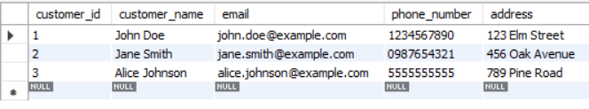

Campaign Table

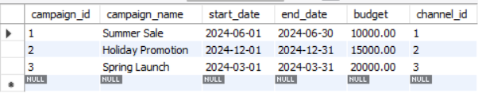

Marketing channel

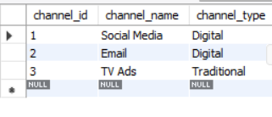

Product

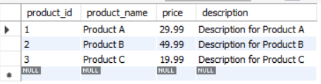

Sales

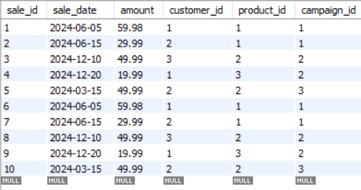

Normal Forms of the Table

Customer Table;

CREATE TABLE Customer (

customer_id INT PRIMARY KEY Unique,

customer_name VARCHAR (100),

email VARCHAR (100),

phone_number VARCHAR (15),

address VARCHAR (255)

);

* **1NF**: The table is in 1NF because all columns contain atomic values, and each column contains a single type of value.
* **2NF**: The table is in 2NF because it has a single-column primary key (customer_id), and all non-key attributes are fully functionally dependent on the primary key.

Product Table

CREATE TABLE Product (

product_id INT AUTO_INCREMENT PRIMARY KEY,

product_name VARCHAR(100),

price DECIMAL(10, 2),

description TEXT

);

* **1NF**: The table is in 1NF because all columns contain atomic values, and each column contains a single type of value.
* **2NF**: The table is in 2NF because it has a single-column primary key (product_id), and all non-key attributes are fully functionally dependent on the primary key.

Marketing Channel Table

CREATE TABLE MarketingChannel (

channel_id INT AUTO_INCREMENT PRIMARY KEY,

channel_name VARCHAR (100),

channel_type VARCHAR (50)

);

* **1NF**: The table is in 1NF because all columns contain atomic values, and each column contains a single type of value.
* **2NF**: The table is in 2NF because it has a single-column primary key (channel_id), and all non-key attributes are fully functionally dependent on the primary key.

Campaign table

CREATE TABLE Campaign (

campaign_id INT AUTO_INCREMENT PRIMARY KEY,

campaign_name VARCHAR (100),

start_date DATE,

end_date DATE,

budget DECIMAL (15, 2),

channel_id INT,

FOREIGN KEY (channel_id) REFERENCES MarketingChannel(channel_id)

);

* **1NF**: The table is in 1NF because all columns contain atomic values, and each column contains a single type of value.
* **2NF**: The table is in 2NF because it has a single-column primary key (campaign_id), and all non-key attributes are fully functionally dependent on the primary key.

Sales Table

CREATE TABLE Sales (

sale_id INT AUTO_INCREMENT PRIMARY KEY,

sale_date DATE, amount DECIMAL(15, 2),

customer_id INT,

product_id INT, campaign_id INT,

FOREIGN KEY (customer_id) REFERENCES Customer(customer_id),

FOREIGN KEY (product_id) REFERENCES Product(product_id),

FOREIGN KEY (campaign_id) REFERENCES Campaign(campaign_id)

);

* **1NF**: The table is in 1NF because all columns contain atomic values, and each column contains a single type of value.
* **2NF**: The table is in 2NF because it has a single-column primary key (sale_id), and all non-key attributes are fully functionally dependent on the primary key.
* **3NF**: The table is in 3NF because there are no transitive dependencies; all attributes are directly dependent on the primary key.

Stress testing

Insertion Function

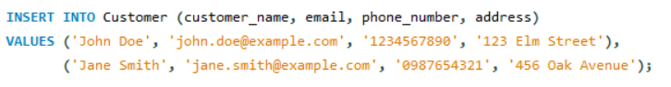

Therefore, the newly Updated table becomes:

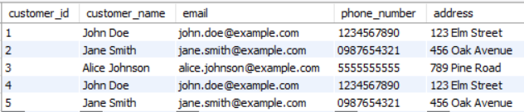

Read operations:





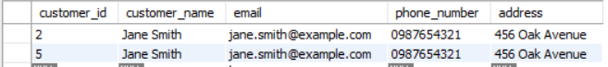

Update Functions:

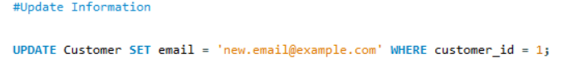

Therefore, the newly updated table becomes:

